If a query has some **dynamic values to be passed**, then represent these dynamic values using variables.

**Hence, the query can be reused by the client applications.**

We will create a simple application to understand the query variable.

## Step 0 − Download and Install Required Dependencies for the Project

Create new package.json file with below code and install all dependencies.

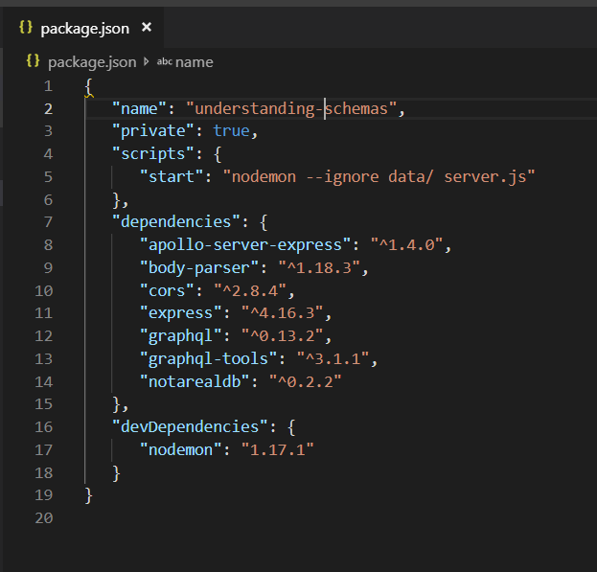

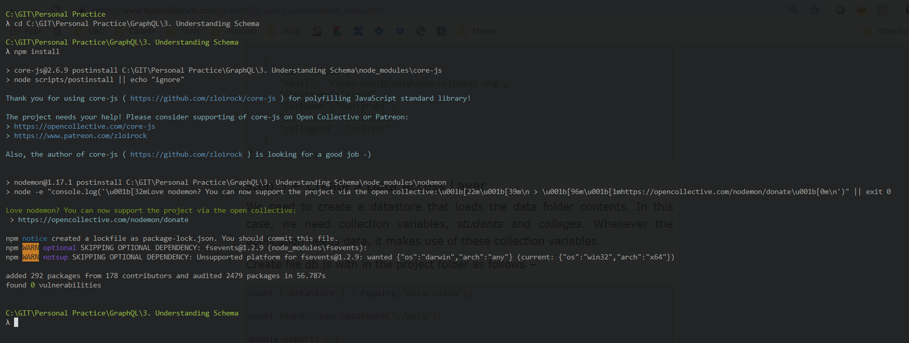

## Step 1 − Edit Schema File

Add a *sayHello* field which takes a string parameter and returns a string.

The **name values** will be dynamic in client application.

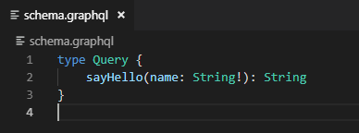

## Step 2 − Edit resolver.js File

Add a *sayHello* resolver which takes parameter

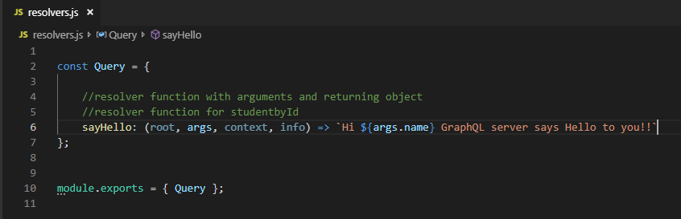

## Step 3 − Declare Query Variable in GraphiQL

A variable is declared with $ followed by name of the variable.

For example: $myname_Variable.

Once $myname_Variable is declared, it has to be used with a named query syntax.

The query, myQuery takes string value and passes it on to sayHello

## Step 4 − Run the Application

Create a server.js file.

